**rina INTERnSHIP**

**User guide**

**DOWNLOAD & ANALYSE**

**SILO DATA**

Team members:

Nguyen Duy Nguyen Ho s372109

Thuy Chi Tran s374211

**TABLE OF CONTENTS**

1. Workflow chart 1

2. Instruction step by step 1

2.1 Request access to github 1

2.2 Go our project on Github 2

2.3 Download source code 2

2.4 Download Anaconda navigator 3

2.5 Launch VS code 3

2.6 Open folder on VS codes 4

2.7 Install Libraries 5

2.8 Run the file Run Fetch_station_list.py 6

2.9 Run the file silo_data_downloader 7

2.10 Run the file silo_data_summarizer 10

# Workflow chart

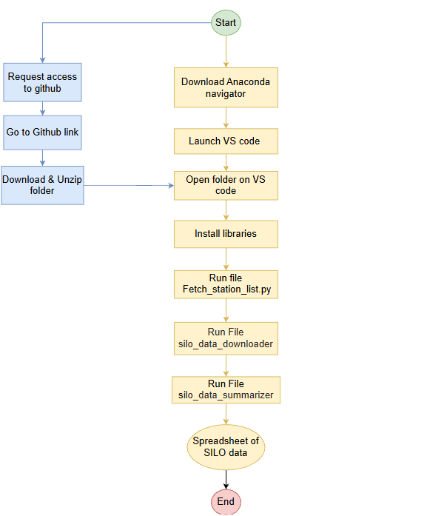

# Instruction step by step

## **2.1 Request access to github**

* Send your email information to Alvin Ho ([s372109@students.cdu.edu.au](mailto:s372109@students.cdu.edu.au)) and message to him to notify your request
* Waiting for his acceptance via email
* Check your email to receive his invitation and click accept

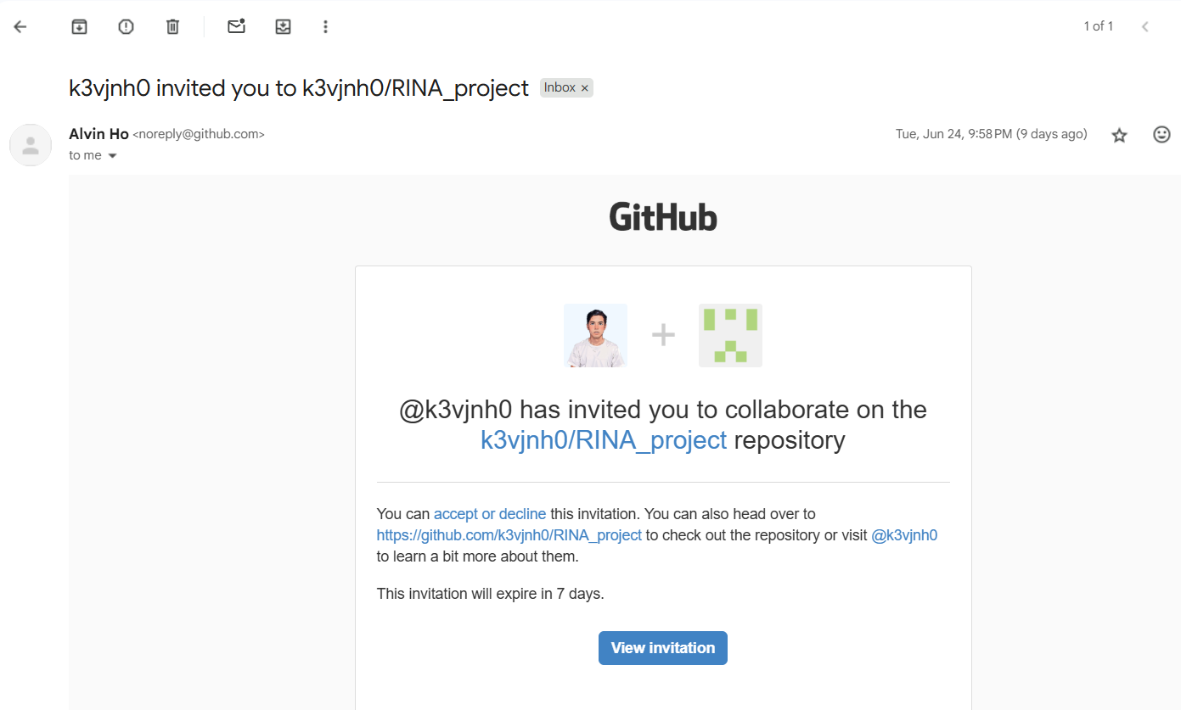

## **2.2 Go our project on Github**

- Click “View invitation” and accept to access to our project

[**https://github.com/k3vjnh0/RINA_project**](https://github.com/k3vjnh0/RINA_project)

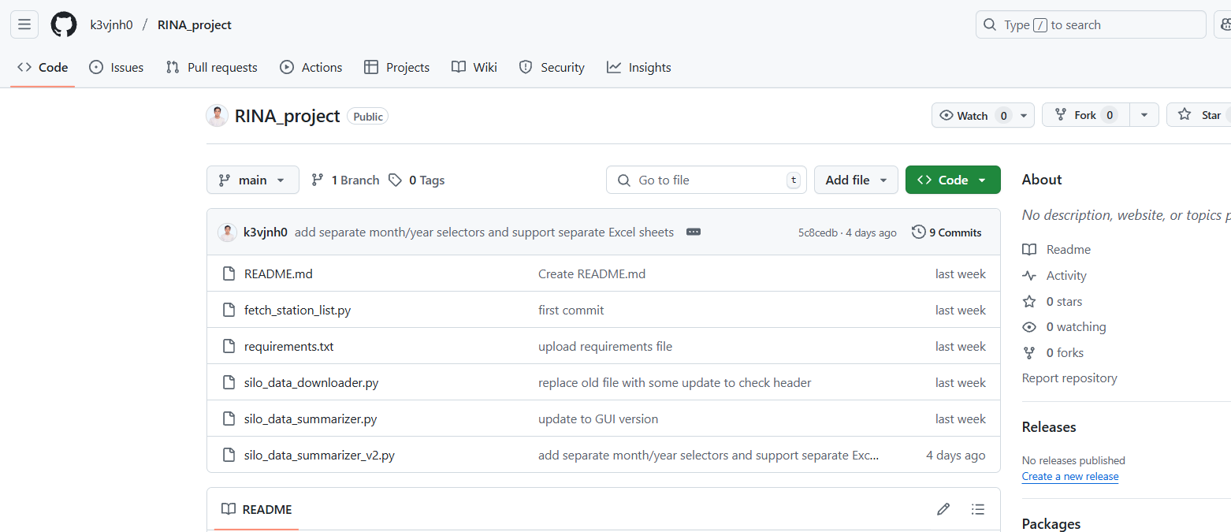

## **2.3 Download source code**

Access to our project: [**https://github.com/k3vjnh0/RINA_project**](https://github.com/k3vjnh0/RINA_project)

Click green button “Code”

Choose “Download ZIP” to download

Download zip file and store in your local PC

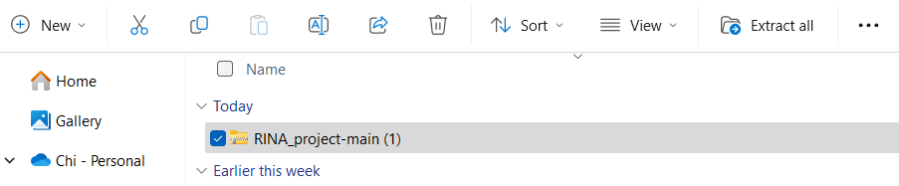

Unzip the folders to view all python files as below

## **2.4 Download Anaconda navigator**

Go to the official site:

1. Download the installer for your OS (Windows/macOS/Linux).

**https://www.anaconda.com/download/success**

Anaconda navigator as below:

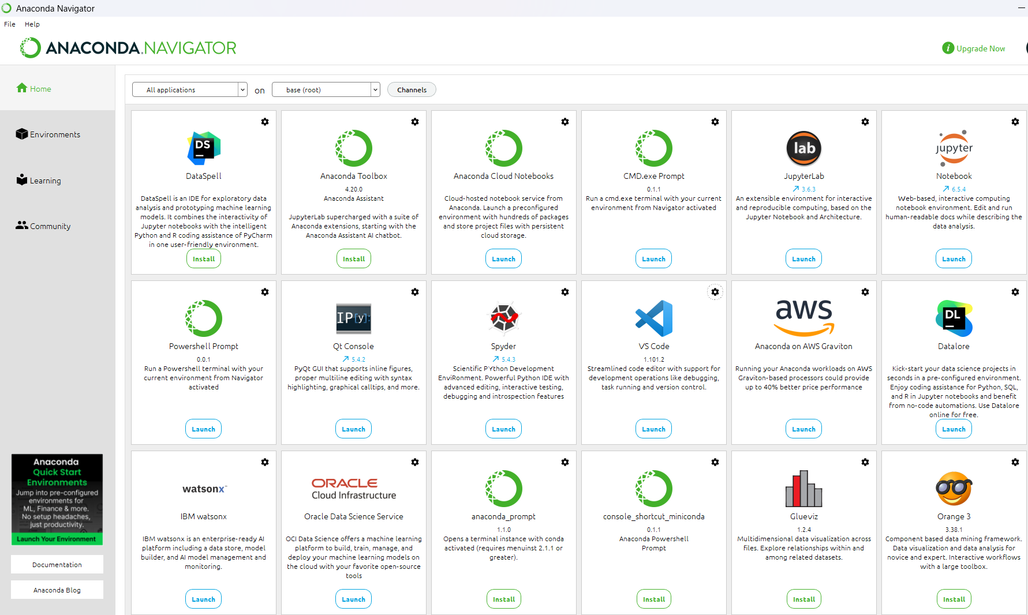

## **2.5 Launch VS code**

Open Anaconda Navigator choose your environment - default base(root) is accepted.

Browse VS code application and click “launch” to open VS code

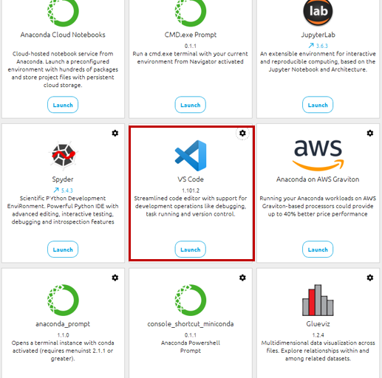

## **2.6 Open folder on VS codes**

After opening VS code, Click open folder

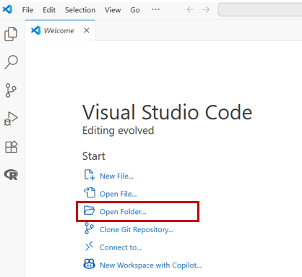

Choose RINA internship folder, which has been downloaded and unzip

VS code displays the python file as below:

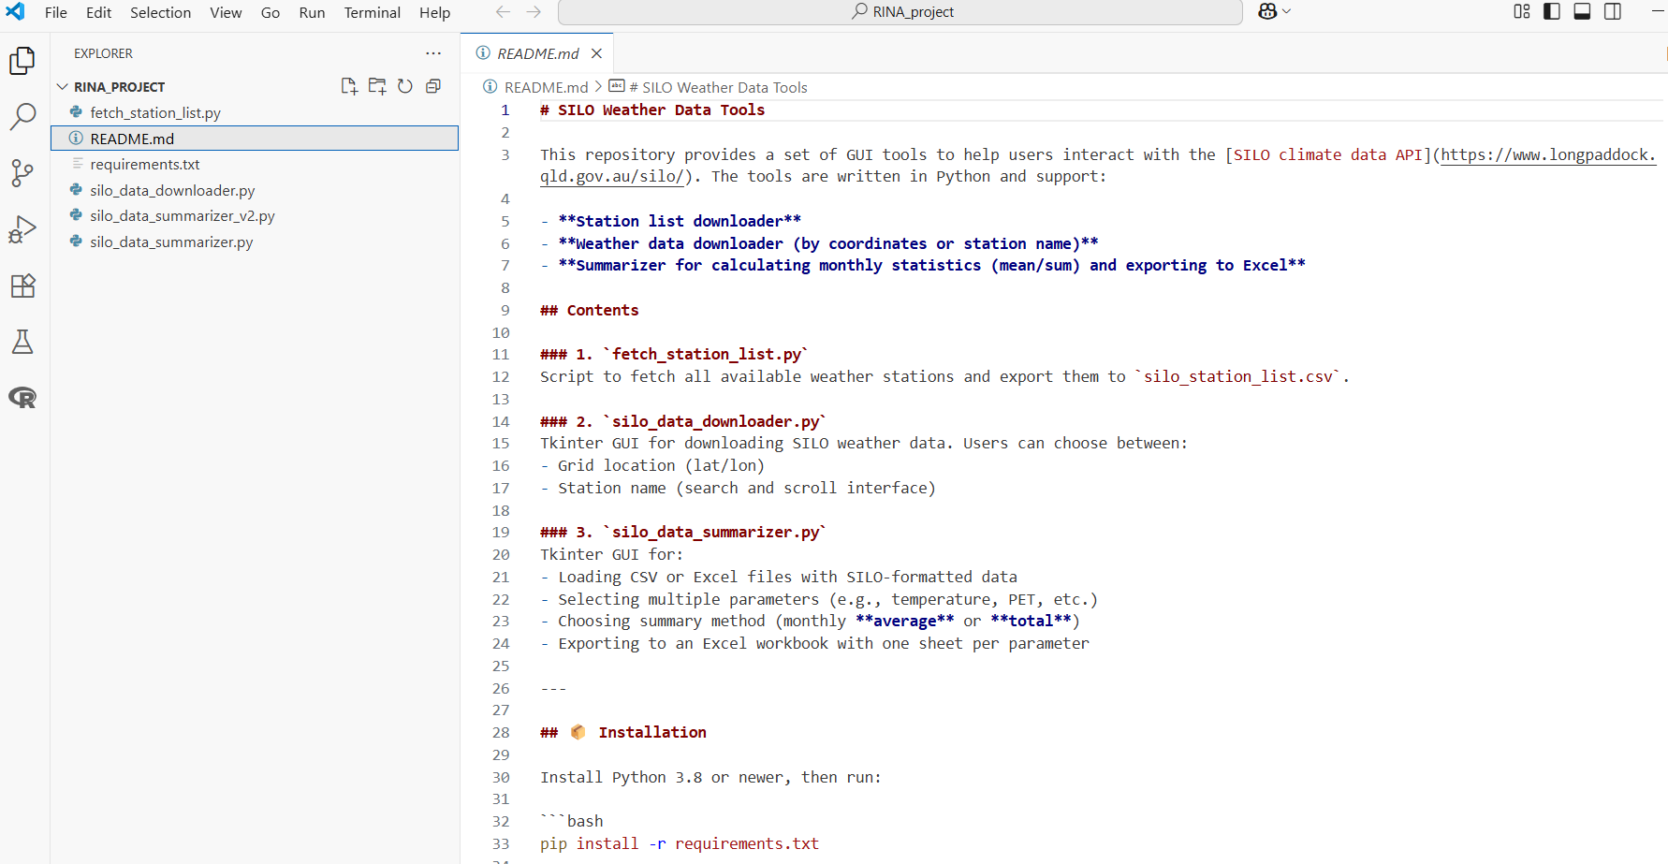

Please open file “Read me” and real information about our project

## **2.7 Install Libraries**

From VS code, click View on the top Menu >> Terminal >>

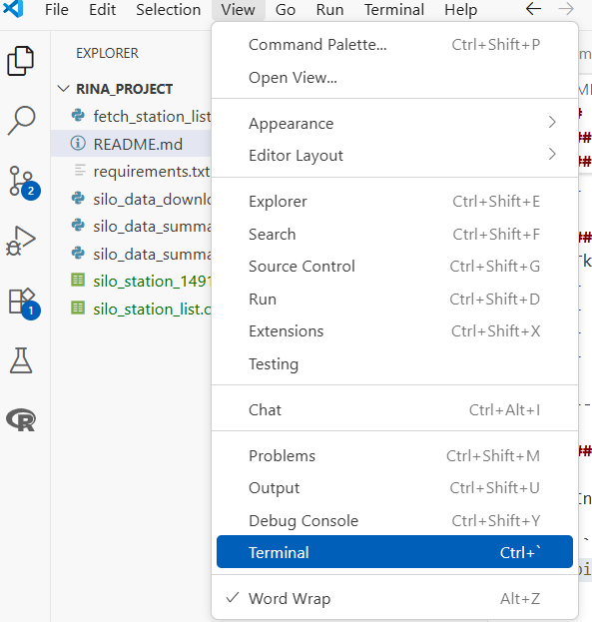

Terminal display as below:

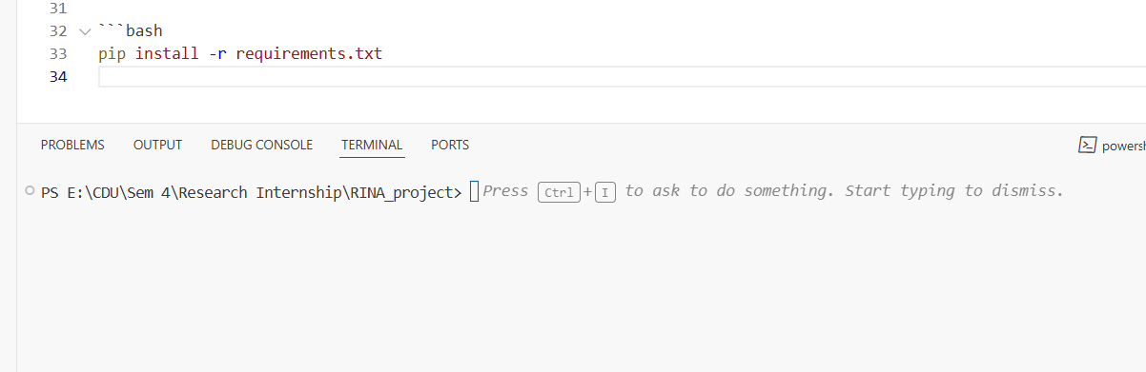

Copy command**: pip install -r requirements.txt** and paste to the terminal to run the command



Next, just wait until the libraries are installed successfully.

## **2.8 Run the file Run Fetch_station_list.py**

Purpose of this step: download master data station list from SILO website

From available folder in VSCode, choose file “Run Fetch_station_list.py” as below:

Click arrow icon (red) to run the file.

Successful step are shown below:

Note: keep the file in the current folder, do not change name or move the file to another folder.

## **2.9 Run the file silo_data_downloader**

This is a Tkinter GUI for downloading SILO weather data.

Users can choose between:

- Grid location (lat/lon)

- Station name (search and scroll interface)

To run the file, choose the file named “silo_data_downloader”

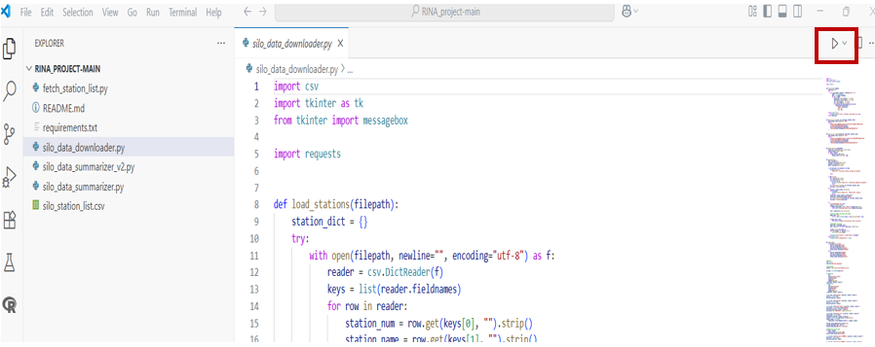

Successful steps are shown below:

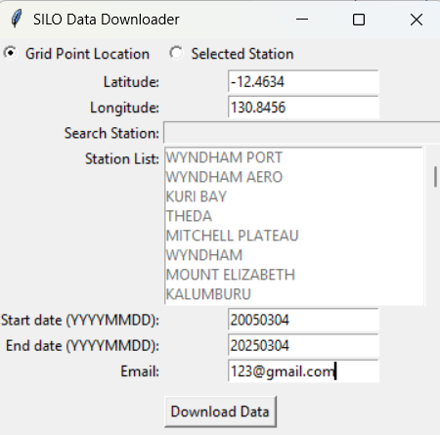

* If you choose Grid location: Latitude, Longitude manually
* If you choose Selected Station: Specific station is selected from Station list
* Start date: format YYYYMMDD, example 20050620
* End date: format YYYYMMDD, example 20250620
* Email: format [X@gmail.com](mailto:X@gmail.com), X is flexible choice
* Click button “Download Data” to run code

Successful steps are shown below:

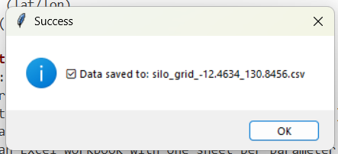

Output file is stored in the current folder as CSV file

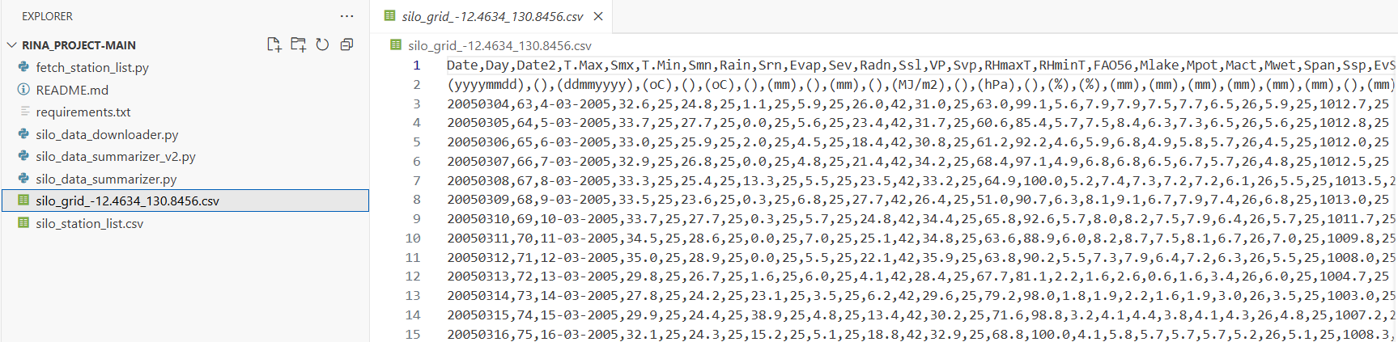

Open the file below:

You can save it as an excel file to conduct further step.

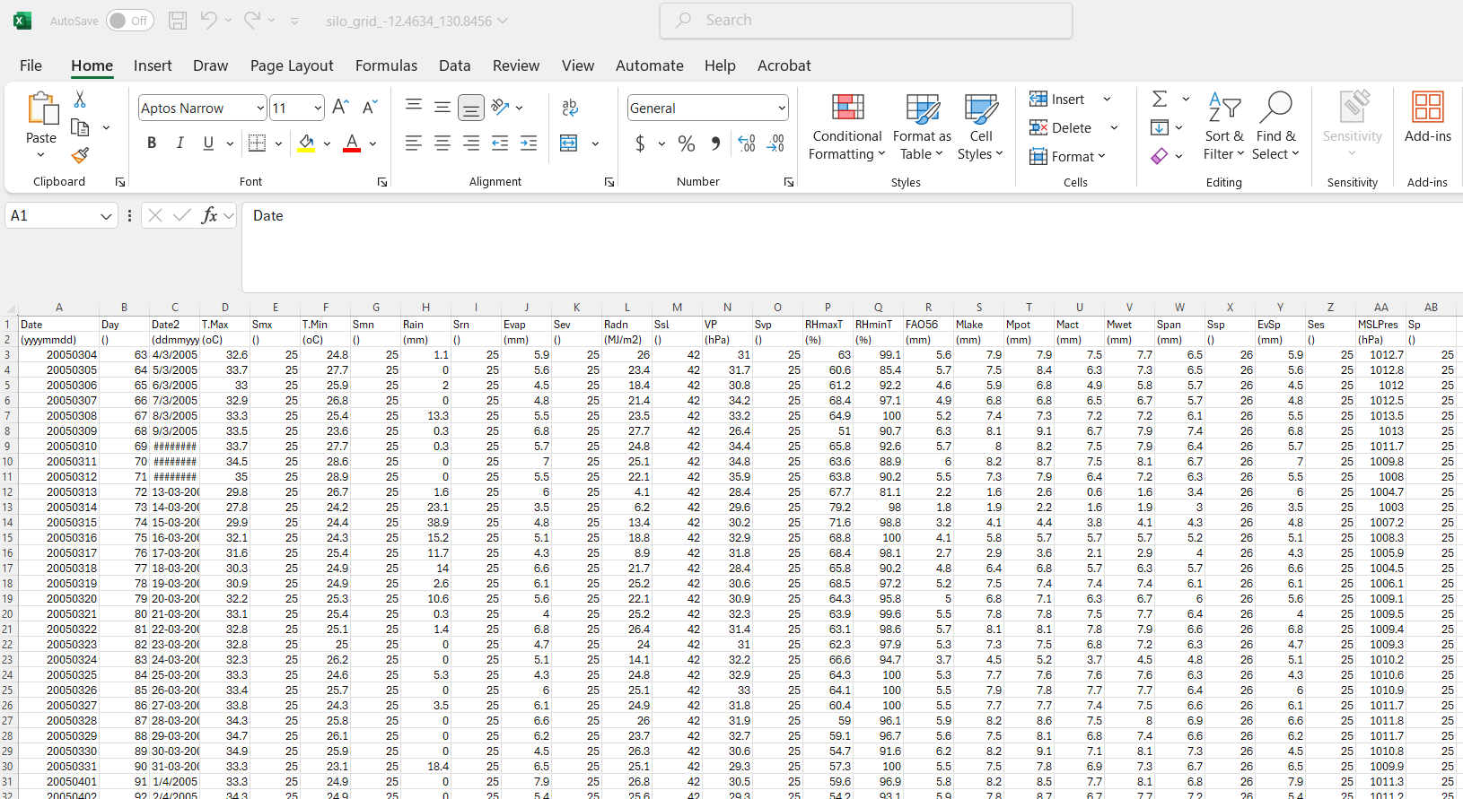

To gain summary or simple transformation, please do the following step.

## **2.10 Run the file silo_data_summarizer**

This Tkinter GUI for:

- Loading CSV or Excel files with SILO-formatted data

- Selecting multiple parameters (e.g., temperature, PET, etc.)

- Choosing summary method (monthly **\*\*average\*\*** or **\*\*total\*\***)

- Exporting to an Excel workbook with one sheet per parameter

To run this GUI, choose the file name “**silo_data_summarizer**” with the latest version, checked by the time

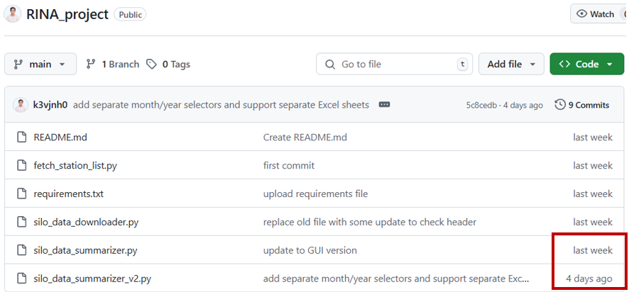

Run the file:

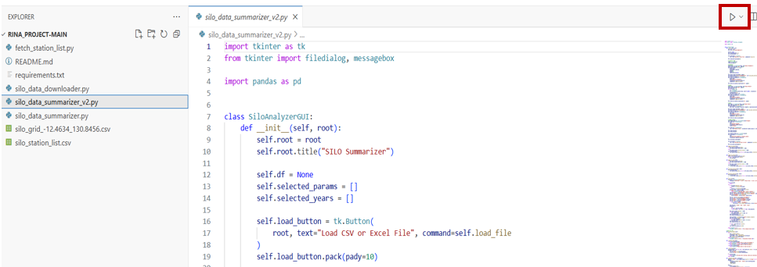

Successful steps are shown below:

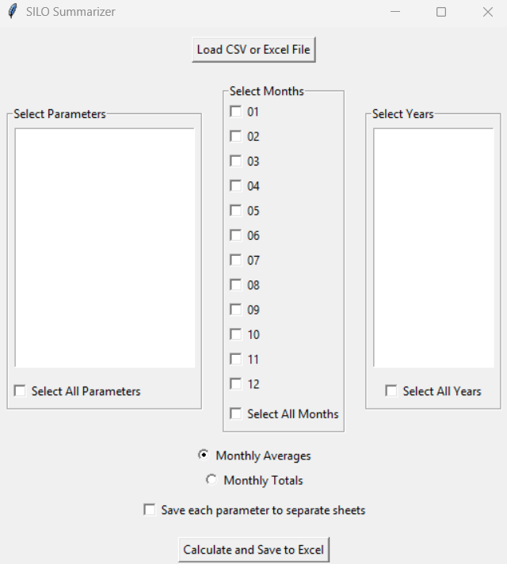

Click button “Load CSV or Excel File” to choose dataset

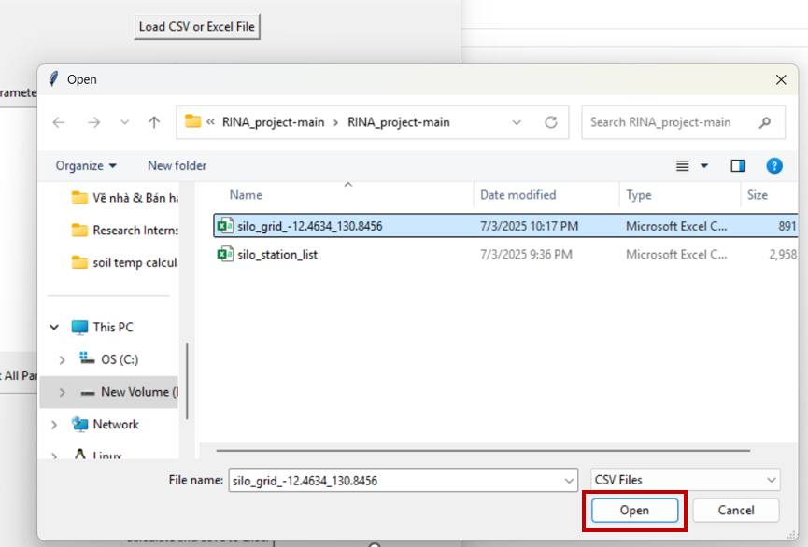

Then, choose parameters, select months and years as needed

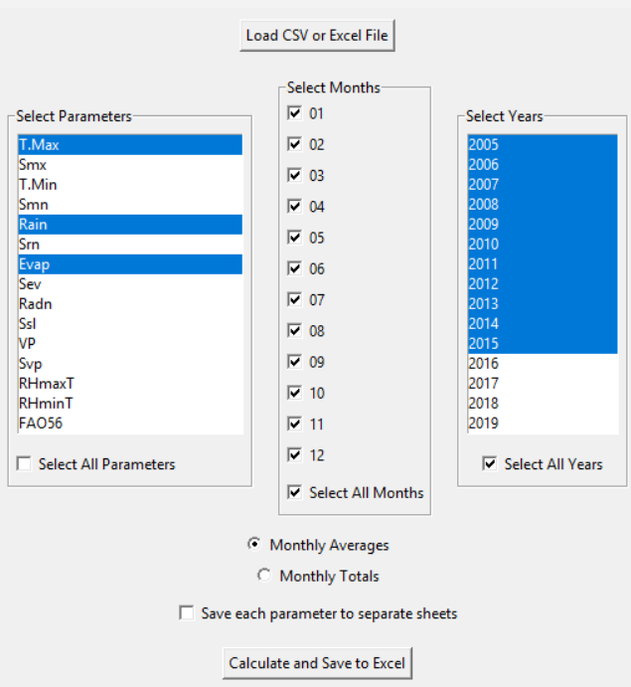

Click “**Calculate and Save to Excel**” to run the request

Successful steps are shown below:

Choose your location and name for the output file, click save to download the file.

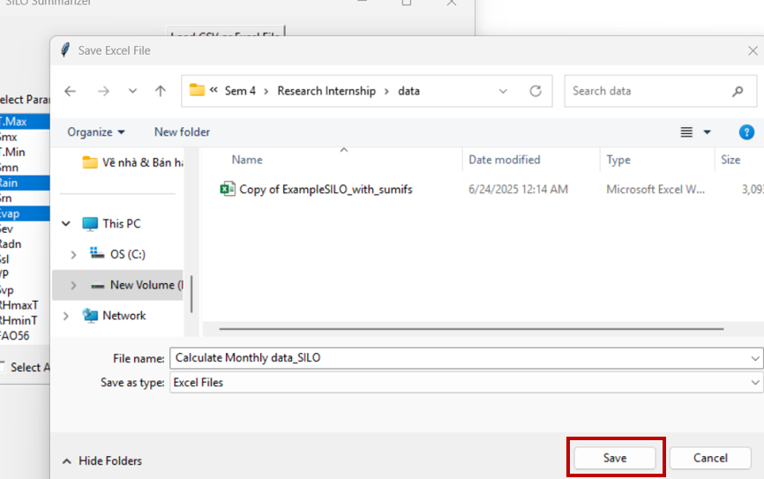

Successful steps are shown below:

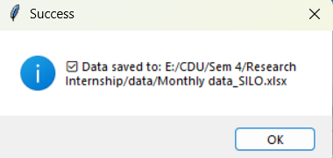

Then, navigate the location of the output file to check the result:

